DAY -4

ZECPATH AI

Project Prepared By Suhail TP

Structured Schema & AI Data Entity Design

1.Problem Statement

Resumes and job descriptions are unstructured documents (PDF, DOC, text). To enable automated ATS scoring, intelligent resume-to-job matching, and scalable hiring workflows, we must convert this unstructured data into structured, machine-readable formats.

2. Solution Overview
- Resume Structured Schema
- Job Description Structured Schema
- AI Data Entity Design
- Organized Project Architecture

3. Resume Structured Schema

The resume schema standardizes candidate information into structured JSON format.
Key Fields:
- Candidate ID
- Personal Information
- Skills (with years of experience and proficiency level)
- Work Experience
- Education
- Certifications- Total Experience
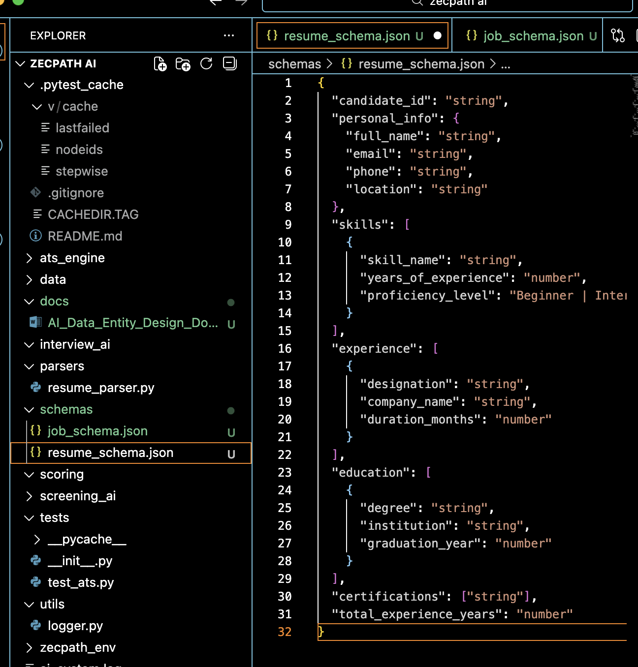

4. Job Description Schema

- The job schema converts job descriptions into structured format.
Key Fields:
- Job ID
- Required Skills
- Minimum Experience
- Skill Priority (High / Medium / Low)
- Education Requirement
-Employment Type
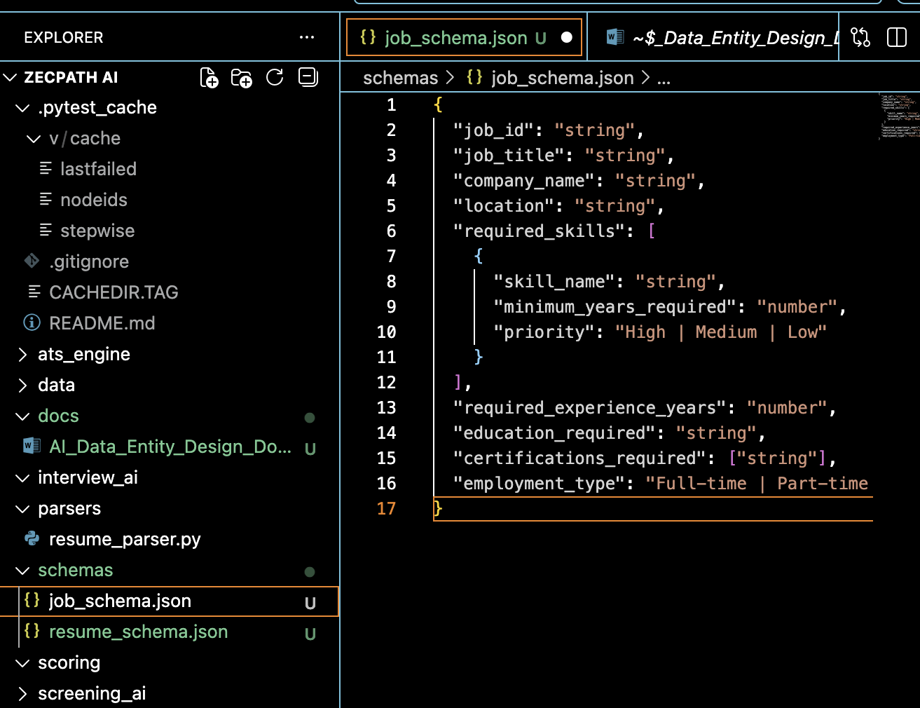

5. AI Data Entity Design

Core Entities Designed:
Candidate Entity:
- Resume Data
- ATS Score
- Screening Score
- Final Status
Job Entity:
- Job Profile
- Applicant List
- Shortlisted Candidates
Skill Entity:
- Normalized skill definitions

6. System Flow

Candidate → Structured Resume → Matched Against Job Schema → ATS Score Generated → Screening Evaluation → Final Decision

7. Technical Benefits

- AI-ready structured data
- Automated skill comparison
- Scalable architecture
- Clean backend design
- Future NLP integration capability

8. Conclusion

Eestablishes the structured data foundation for the Zecpath AI Hiring System. This enables intelligent resume matching, automated scoring, and scalable AI-driven hiring workflows.

